Logic Lab Car Activity

<http://www.neuroproductions.be/logic-lab/>

Note: This is a puzzle for you to try and solve. Your job is to experiment by adding logic gates, wire splitters, etc. until you succeed on hitting all the criteria of the challenge. You will not only get marked on the completion of Challenge #1. The remaining challenges, however are required for you to attempt.

**Challenge #1: Gas and Brake**

Setup your screen such a the following image. You will need 4 propellers (your wheels), 2 switches and 1 or 2 splitters.

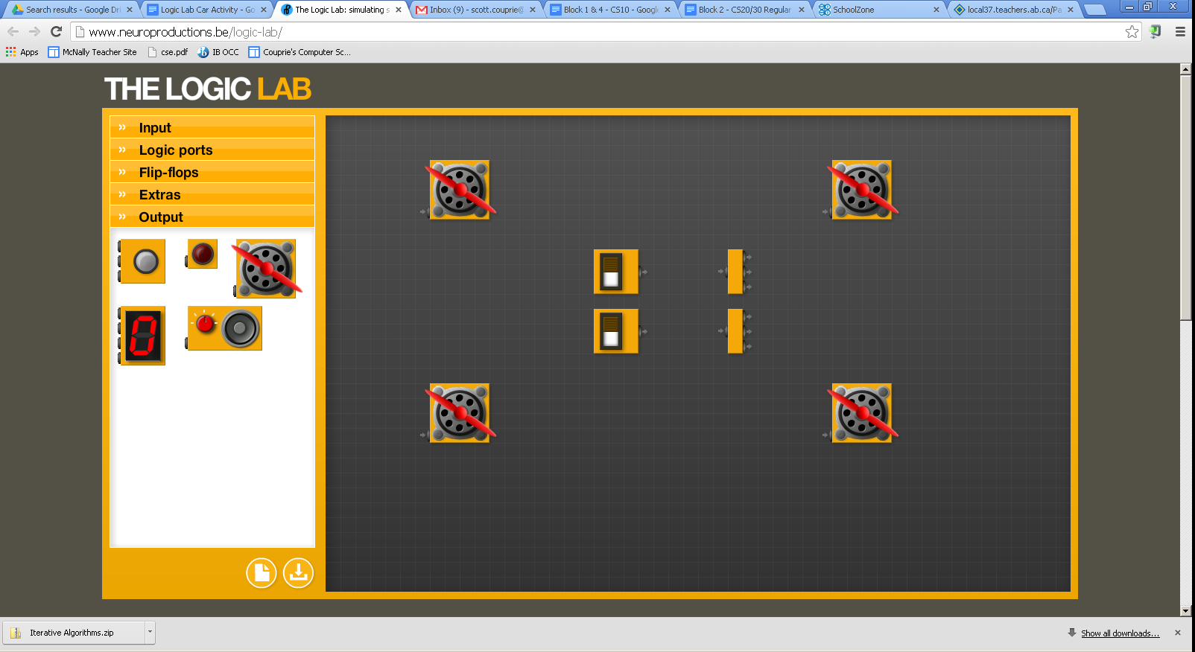

Assume the top pedal is the brake. The bottom is the gas.

Program the car with the following features:

* when the gas pedal is pressed (bottom switch), all four wheels start to spin (unless the brake is also pressed)
* when the brake is pressed, all four wheels will be stopped
* when the brake and gas is pressed, the engine should just rev (in other words, all four wheels will be stopped)

**Challenge #2: Turning**

Building off your existing car, add 2 buttons (to act as the turn switches), 2 lights and a power pulser (plus possibly a splitter for the pulser). See picture below.

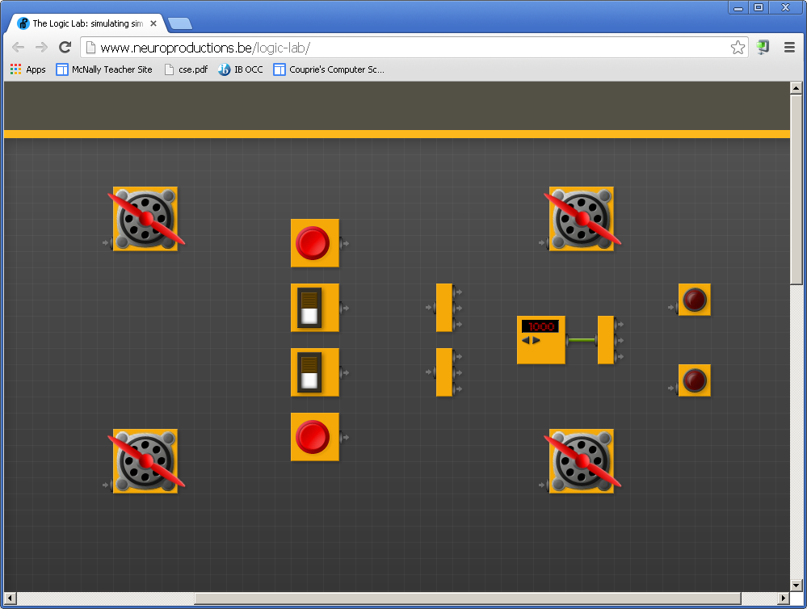

Turning will be indicated by having only 2 of the wheels spinning (like for a tank) and the appropriate light is on or flashing. Turning left will mean the top two wheels will be stopped. Turning right will mean the bottom two wheels will be stopped. Then program the car with the following features:

* when the gas pedal is pressed AND the right turn signal is on, the car will turn right (bottom wheels off, lower light flashing)
* when the gas pedal is pressed AND the left turn signal is on, the car will turn left
* if the gas pedal is not pressed, the turn signals will not do anything
* for this scenario, you do NOT need to worry about the cases where both signals are pressed or when both the brake and gas pedals are pressed

**Extra challenges/Options:**

You have two choices:

1. Continue working on the tough car challenges described on the next page
2. Go learn about electrical circuits in general. <http://thefusebox.northernpowergrid.com/page/circuitbuilder.cfm> This will start easy but get more complex. It is not directly related to Computing Science, but the more you know about electricity flow, the better you will understand how electricity (and data) flows on the BUS in the computer.

More Logic Lab Car Challenges

Here are some fun things to try if you have time:

* add brake lights
* add a bumper that will turn off the engine in the event of a crash
* add a speedometer. Use multiple switches to represent how far down you are pressing the gas pedal and then wire in the counter to show your speed.
* add whatever else you can think of

When finished, save this set up and record the web address in your Logic Gates assignment from last class so that I can view it later.